|  |
| --- |
| 新东方在线英语学习 |
| 新概念 2 册 |
| Lesson41 |



扫一扫。更多有趣的英语资讯。

1. rude adj. 无理的

rudely adv. 无理地

A rude man was shouting rudely.

1. mirror n. 镜子

look at oneself in the mirror

hole [həul] n.孔

1. remark v. 评说

n. 评论

1. remind v. 提醒remind sb. of sth. remind sb. to do sth.

reminder n. 提醒，提示物

lighthouse ['laithaus] n.灯塔

# Lesson 41 单词讲解

Key points: need

1. 作实义动词
2. 作情态动词

need

1. 实义动词
   * 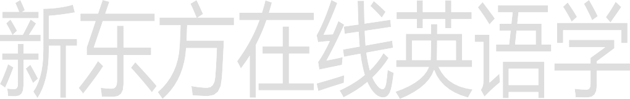need sth.

# Lesson 41 课文&语法讲解

* + need to do / need sb. to do
  + need doing 需要被。。。。
  + He needs some time.
  + He needs to have a rest.
  + He needs friends to help him.
  + His bag needs mending.
  + 否定形式：
  + don’t need
  + doesn’t / didn’t / won’t need

1. 情态动词
   * need do

(常用于否定疑问)

* + Need I finish it now?
  + You needn’t finish it now.
  + need have done
  + 否定形式：needn’t

1. “You needn’t be so rude … ,” my wife answered as she looked at herself in the mirror. need 情态动词

needn’t

need + 动词原形

With 介词 名词代词动名词

With 有的意思 with sth in /on 伴随着有。。。在哪里

1. I sat down on one of those modern chairs with holes in it … a piece of paper with her name and address on it

a wallet with 200 dollars in it

a bus with 50 people on it

1. We had been in the … shop for half an hour and my wife was still in front of the mirror. She is sitting in the front of the bus.

In front of 一个东西 外部的前面

in the front of 里面的前面

1. “We mustn’t buy things we don’t need,” I remarked suddenly. mustn’t 情态动词 “禁止，不允许”

things we don’t need 定语从句

1. “We mustn’t buy things we don’t need,” I remarked suddenly. things we don’t need 定语从句

need 实义动词

don’t need need + things

1. I regretted saying it almost at once. regret regretted regretted regret sth.

regret doing sth.

1. “You needn’t have said that,” my wife answered. need have done

本来需要做某事，但事实上没做

（虚拟）



needn’t have done

本来不需要做某事，但事实上做了

7. “I needn’t remind you of that … tie you bought yesterday.” remind sb. of sth.

that … tie you bought yesterday

定语从句

1. “You needn’t have said that,” my wife answered.

needn’t have done 本来不需要做某事，但事实上做了

（虚拟）

1. “I needn’t remind you of that … tie you bought yesterday.” needn’t do 不需要做，就真的不做

（真实）

1. “A man can never have too many ties.”

“… a woman can’t have too many hats,” …

1. My wife was wearing a hat that looked like a lighthouse.

定语从句

look like

She looks like her father.

# Lesson 41 知识拓展

**高考的考点**：

情态动词 needn’t

I use a clock to wake me up because at six o’clock each morning the train comes by my house.

1. couldn’t
2. mustn’t
3. shouldn’t
4. needn’t

(2012 课标 全国 30)

I use a clock to wake me up because at six o’clock each morning the train comes by my house.

1. couldn’t
2. mustn’t
3. shouldn’t
4. needn’t

(2012 课标 全国 30)

It’s quite warm here; we turn the heating on yet.

1. couldn’t
2. mustn’t
3. needn’t
4. wouldn’t (2012 天津 8)

It’s quite warm here; we turn the heating on yet.

A. couldn’t



1. mustn’t
2. needn’t
3. wouldn’t (2012 天津 8)

I worry about my weekend – I always have my plans ready before it comes.

1. can’t
2. mustn’t
3. daren’t
4. needn’t

(2011 上海 28)

I worry about my weekend – I always have my plans ready before it comes.

1. can’t
2. mustn’t
3. daren’t
4. needn’t

(2011 上海 28)

* What sort of house do you want to have? Something big?
* Well, it
  1. mustn’t
  2. needn’t
  3. can’t
  4. won’t (2008 陕西 9)

be big – that’s not important.

* What sort of house do you want to have? Something big?
* Well, it be big – that’s not important.

1. mustn’t
2. needn’t
3. can’t
4. won’t (2008 陕西 9)

